QUALITY
POLICY

CENTURION SAFETY PRODUCTS LTD

Purpose of this policy 3
Delivering our policy 3
1. Quality Policy 3
2. Overview of core processes 5
Policy Owner 6
Review 6
Version Control 6

Purpose of this policy

Centurion Safety Products was established in 1879 and is an ISO9001: 2015 registered company registered in the UK (Registration Number: 13067) with global headquarters in Thetford, England.

The Quality of our products and service is of critical importance to our business because we value the safety of our customers and end users. We strive to provide our customers with products and services which meet and even exceed their expectations.

The company’s strategy is to focus exclusively on head protection systems (personal protective equipment) for those at work. The Design, Management, Development and Manufacture of all of the products produced and sold by Centurion Safety Products Ltd, is carried out in accordance with the applicable regulatory requirements including but not limited to, the BSI Kitemark and PPE Regulation 2016/425.

Delivering our policy

Evidence of compliance with ISO 9001:2015 Quality Management system is available within our Integrated Management system. A flow chart demonstrating the core and supporting activities is detailed below.

Quality Policy

Working closely with all our stakeholders (employees, shareholders, customers, end users, suppliers and the local community) our Quality Policy, and the procedures/processes flowing from it, support us in our aspiration to design and manufacture the worlds’ most advanced and intuitive head protection systems, facilitating our aspiration to be the global expert in total head safety at work.

Centurion undertakes to supply only safety equipment and/or related services that fully comply with the standards and regulations and claims made relating to those products and/or related services. Where appropriate, Centurion will maintain up to date technical files and associated documentation to ensure that regulatory compliance information can be supplied upon request.
Where products are sourced from external organisations which hold technical files relating to the products being offered, Centurion will request confirmation that these files are current, complete, contain appropriate conformity assessment information and, where relevant, regulatory compliance certificates and will take all necessary steps to confirm the validity of the compliance documentation held by that external supplier in respect of the products being sourced.
Where services are provided related to safety equipment sourced from external organisations, Centurion will maintain approval from the manufacturer that the services provided are assessed and approved by the external organisation.

The Quality Policy provides a practicable sustainability framework supporting economic, and, ethical growth across our supply chains.

Clear communication of all relevant targets and KPI’s is an important mechanism for our people which helps them to understand how they fit in to our business and how they can maximise their contribution by organisational, people, and process development.

This is supported by a risk-based approach to systemic root cause analysis investigations and continuous improvement initiatives, resulting in a sustained Quality & OTIF performance.

The following systems and procedures are in place to support us in our aim of total customer satisfaction and continuous improvement throughout our business:
- regular gathering and monitoring of customer feedback.
- a customer complaints & investigation procedure
- selection and performance monitoring of suppliers against set criteria
- training and development for our employees
- regular audit of our internal processes
- measurable quality objectives which reflect our business goals
- management reviews of audit results, customer feedback and complaints

For and on behalf of Centurion Safety Products Ltd.

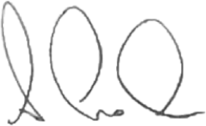
Allan Lock
CEO

July 2026

2. Overview of core processes

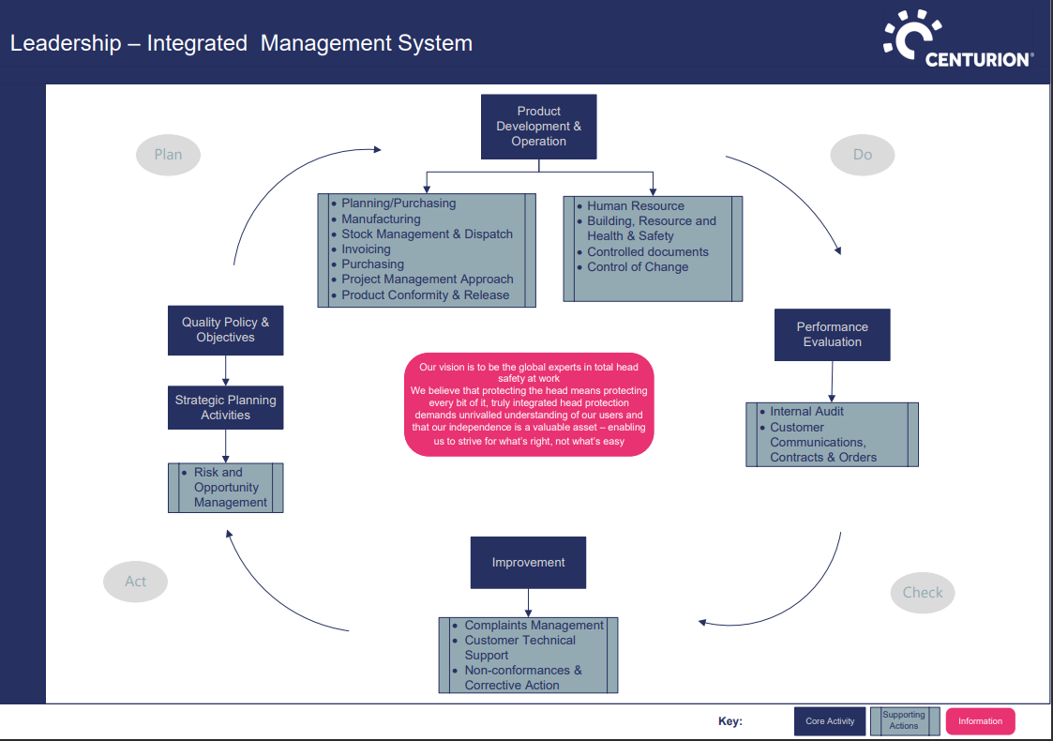

Policy Owner

Samantha Austin

Head of Compliance

Review

July 2027

Version Control

Warning: Print copies not subjected to version control

